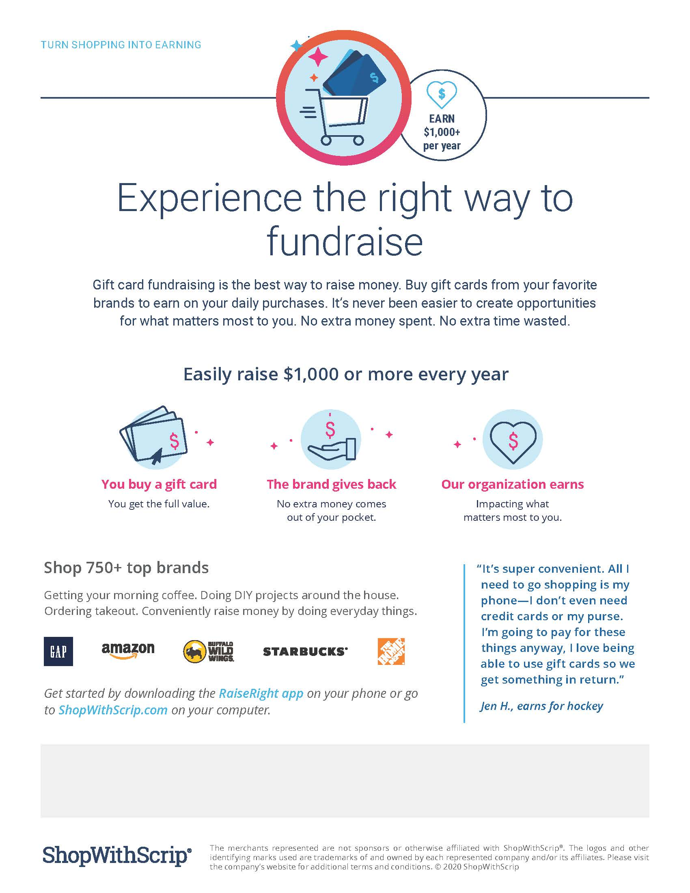

Go to [www.shopwithscrip.com](http://www.shopwithscrip.com), and click on “Join A Program” Enter our organization’s unique enrollment code: **1B82B7EL41487** and complete your registration by creating a username & password and filling out your personal information. REMEMBER TO ADD YOUR STUDENT’S NAME TO RECEIVE CREDIT FOR YOUR PURCHASES.

You can begin shopping by clicking on the shopping tab OR use the search bar to look for specific vendors.