Attention Central Sound and Sweet Sensation!!

Want to order your sweatshirts and sweatpants before show season?

Here is your chance!

Go to:
https://lchschoir.itemorder.com/sale

and order your gear!

** If you ordered these last year, they are the same. There is no need to order again unless you switched choirs or need to replace something!

Show t-shirts will be ordered next semester.
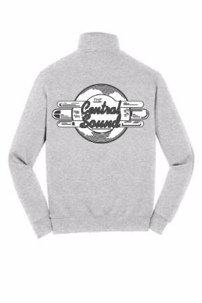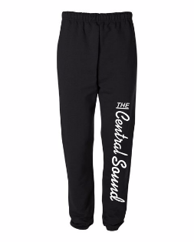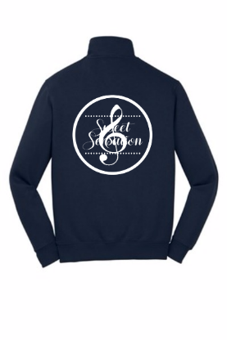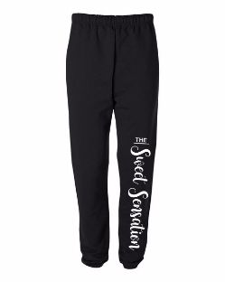

* Pants have pockets!

